Q 1 Write a command that puts the following values, in their given order, into the salespeople table: city – San Jose,name – Blanco, comm -Null , cnum – 1100.

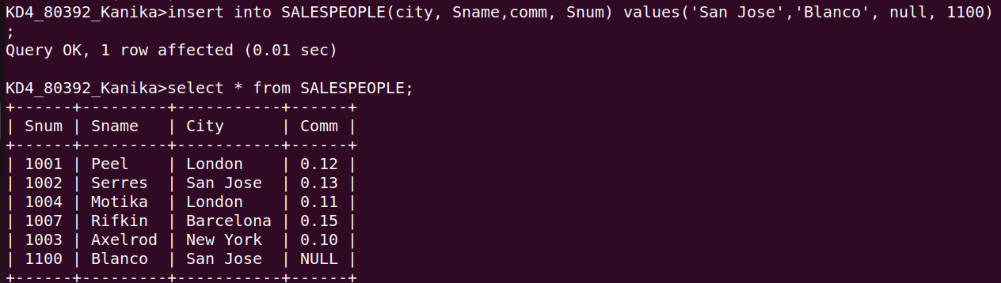

Q 2 Write a command that removes all orders from customer Clemens from the ORDERS table.

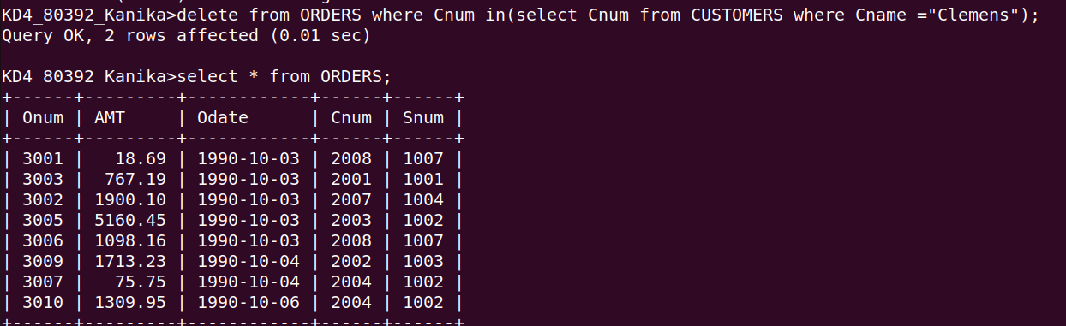

Q 3 Write a commmand that increases the rating of all customers in ROME by 100.

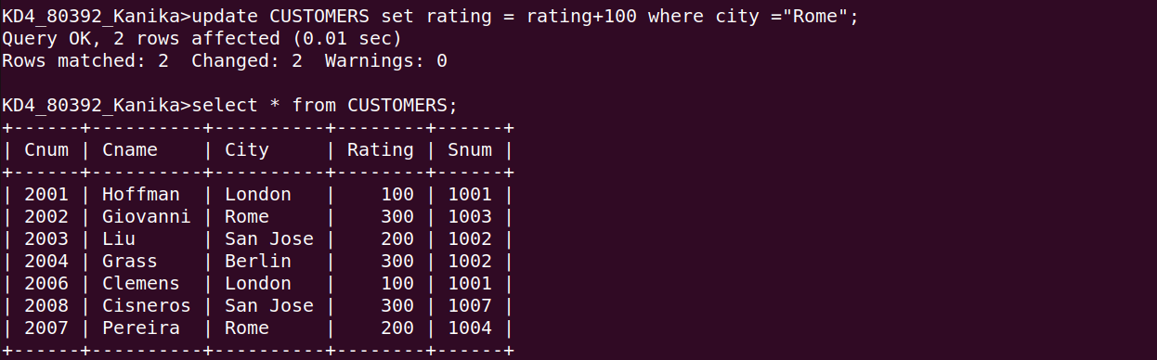
Q 4 Salesperson SERRES has left the company. Assign her customers to MOTIKA.

